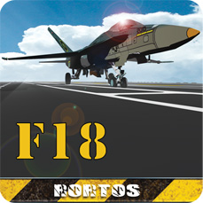
Italy, May 25th 2012.
F18 Carrier Landing new release is available.
A new release for a real experience, with new settings for a worldwide challenge.
The flight Simulator’s iOS compatible with iPhone 3GS/4+, iPad, iPod Touch 3rd/4th+ has been further improved. After having gained the first places in the Apple Store the Ferrari of the flight, came back for a new landing experience .
A stunning new graphics and an interface that runs perfectly on the new Resolutionary iPad as on Smartphones with iOS and Android operating systems; a new aircraft, the F-14 Tomcat, a plane we have all seen flying in Top Gun; new game modalities and training tools; new scores and trophies modality; new realistic controls behavior mode to perform every kind of figure; new external camera banking mode, accurate aircraft performance and behavior and a replay 20 seconds function.
The new version also evaluates the player performance by assigning a score that can be shared in the Game Center and on social media. For a worldwide challenge! Lets follow F18 Carrier Landing evolution, share your score and post your images on Twitter and Facebook!
Happy Landing!
CONTATTI
PR Manager
pr@rortos.com
Skype: pr.rortos

Lets follow our Social Channels. Here below you’ll find the link you can publish on your website or Blog!


http://twitter.com/#!/rortos


http://www.facebook.com/F18CarrierLanding


http://plus.google.com/s/f18%20carrier%20landing

www.f18carrierlanding.com

