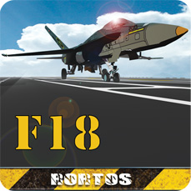
Italy, May 25th 2012.
F18 Carrier Landing new release is available.
A new release for a real experience, with new settings for a worldwide challenge.

KEYWORDS

EXTERNAL CAMERA
REPLAY FUNCTION
SOCIAL SCORE SHARING
REAL EXPERIENCE
WORLDWIDE CHALLENGE
F/A-18 HORNET: THE FERRARI OF FLIGHT
F-14 TOMCAT: TOP GUN AIRCRAFT
STUNNING NEW GRAPHIC
TUTORIALS&TRAINING MODE
“RECTANGLES” CHALLENGE
SCORES AND TROPHIES
PRECISE FLIGHT CONTROLS
LANDING LIGHTS
REALISTIC CONTROLS
FIGURES PERFORMER
FACEBOOK
TWITTER
HAPPY LANDING

CONTATTI
PR Manager
pr@rortos.com
Skype: pr.rortos

Lets follow our Social Channels. Here below you’ll find the link you can publish on your website or Blog!


http://twitter.com/#!/rortos


http://www.facebook.com/F18CarrierLanding


http://plus.google.com/s/f18%20carrier%20landing

www.f18carrierlanding.com

